Team | Start | 2 | 3 | 4 | 5 | 6 | 7 | 8 | final
Team A | Locker | MCA Corridor | Water (Spy) | Food Court | Krishna Corridor | registration | Staffroom | Outdoor | classroom
Team B | Food Court | Water (Spy) | registartion | Locker | MCA Corridor | Krishna Corridor | Staffroom | Outdoor | classroom
Team C | Water (Spy) | Krishna Corridor | Locker | MCA corridor | registration | Food court | Staffroom | Outdoor | classroom
Team D | Krishna Corridor | registration | Food court | Water (Spy) | Locker | Mca corriodor | Staffroom | Outdoor | classroom
Team E | MCA Corridor | locker | Krishna corridor | registration | Food court | Water (spy) | Staffroom | Outdoor | classroom
Team F | registration | Food Court | MCA corridor | Krishna Corridor | Water (Spy) | locker | Staffroom | Outdoor | classroom

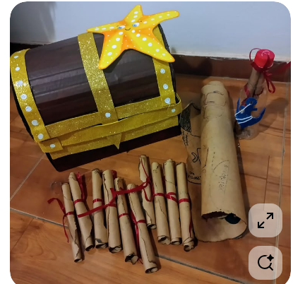
THIS IS FINAL TRESURE BOX-IMG1

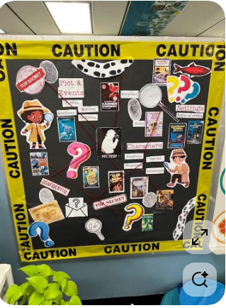
CLASSROOM DECORATION
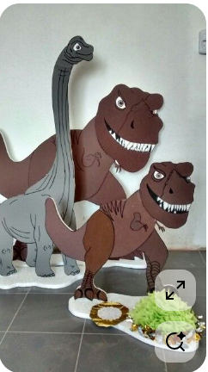
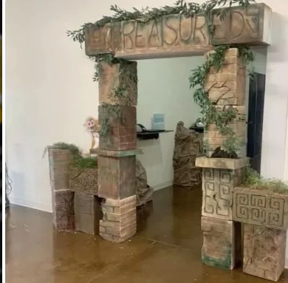
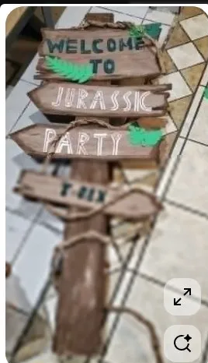
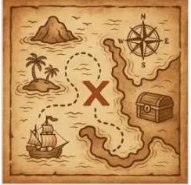

RULES:
1..LIKE WE KEEP TIME LIMIT GAME FROM 10 TO 1 30 IN THAT THEY SHOULD FINISH OTHERWISE WHO IS AT FIRST AND TIME TOOK AND IN THAT BASIS PRIZE WILL DISTRIBUTED

